**Testing Standard Operating Procedure for Projects**

# Discipline: Software Testing For Projects.

## Purpose

The purpose of these SOPs is to guide software testing activities in order to ensure a standard level of quality and repeatability on all New / existing available software projects. Its drives based on the **PDCA** Process.

## Scope

The scope of these SOPs is all software testing activities for all Agira Technologies software engineering for New / existing projects.

**New Project / Existing Project:**

* QA team needs to understand the project size and project period.
* Need to understand the project Technologies and platform (Domain) what we are going to use.
* Need to know the team members.
* Need to know what process we are going to follow for the project.
* Go through the project related documents or architecture for understanding.
* Based on the reviewing documents QA needs to raise a question in the questionnaire sheet.

**QA Needs to Prepare the below documents:**

* Preparation on Test Plan
* Review on the stories assigned in sprint which is DEV phase itself.
* QA needs to estimate on the stories.
* Preparation on Test Scenarios
* Based on Test Scenarios preparing the Test Cases
* Preparation on Functional Test Cases.
* Segregation on Test cases as (Smoke Test Cases, Regression Test Cases and if applicable Automation Test Cases).
* Based on Test Cases if automation is applicable QA will prioritize which is automatable and not automatable planning will be doing.
* Once the execution is completed the RTM (Requirement Traceability Matrix) need to prepare for coverage.
* Test Closure status sprint wise sharing with team from QA for every sprint closure day.
* Preparation on Release Plan once the code is push to UAT (Staging) delivery to client.
* QA Post Validation certification need to send when release to staging client / production.

**Following the General Process:**

* Deploying the Changes through build in QA Environment.
* Testing the New Requirement Points/ Client Issue testing in the QA / Integration Environment.
* Smoke Testing.
* Functional Testing.
* Integration Testing if applicable for API testing.
* Usability Testing
* Regression Testing.
* DBA Testing if applicable for the project.
* Compatibility Testing if applicable for the project.
* Security Testing if applicable for the project.
* Load Testing if applicable for the project.
* Creating new Test Cases / updating the existing Test cases.
* Executing Test Cases in the Test Environment.
* Managing Testing Related Documents.
* Defect Management.
* Testing in the Staging Environment on regression phase.
* Testing in the Preprod Environment on regression phase.
* Testing High level in production testing if applicable.

**1.3 General WorkFlow:**

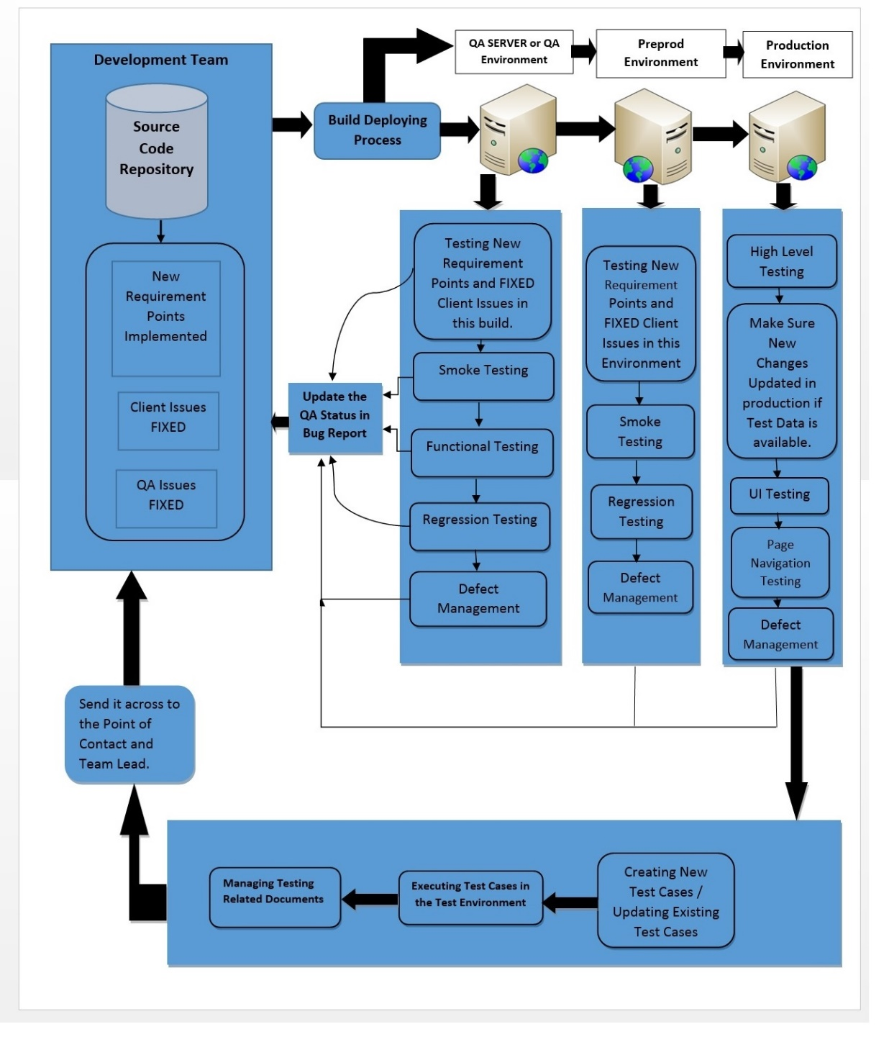

# SOP: Deploying the Changes through build in QA Environment.

## Purpose

The purpose of this SOP is to guide the Testing Team what are the Requirement changes and Client Issue Fix updated in this build.

Before Deploying the Build Test Analyst as to understand the requirement Changes and Client Issues Fix done by Development Team.

## Scope

The scope of this SOP both Development Team and QA Team needs to coordinate and understand the changes done in this build.

## Roles

| **Role** | **Responsibilities** |
| --- | --- |
| Developers | * Deploy the Requirement Changes and Client Issue fixes in the QA Environment. * Coordinate with QA Team to share what are the changes has been done in this build. * Make sure the High-level Acceptance Criteria mentioned in the story card or in the comments by the Developers when development stage. |
| QA | * Making sure the Test Plan is ready. * Test Cases and segregation on Test Cases. * Defect Management and Tracking. * Coordinating with BA Team. * Coordinating with Development Team. * Analysis on the stories / Defect. * Raising Question in Story Time / Grooming Call. * Raising Question in scrum meeting * Coordinating with QA Team. * Discussing about Scenarios within the QA Team. * Make sure everything is going as per the Requirement and Release. * Coordinating with Business Analyst if required. * Need to Understand what the Requirement Changes and Client Issue fixes are done in this build. * Think about the New Scenarios related to new changes. * When executing test cases make sure impact areas functionality also * Creating Test Scenarios for the New Requirement Changes and Client Issue fixes. * Based on the planned Internal Demo / Client demo QA has to follow and prioritize the defects or story which is not deliverable from DEV. Echo in the sprint meeting / in proper group slack channel to prioritize with DEV team before the demo make sure it should be ready. * Final Project Test Closure from QA. |
|  |  |